**PROJECT DOCUMENTATION**

1. BACKGROUND

Sporty Shoes is a company that manufactures and sells sports shoes. They have a walk-in store, and now, they wish to launch their ecommerce portal sportyshoes.com.

1. PROJECT GOAL

To develop a prototype of the application.

It will be then presented to the relevant stakeholders for budget approval.

1. SPRINT PLANNING

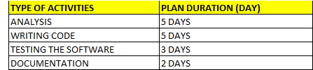

Refer to attached Appendix A for detail Sprint planning.

1. TOOLS

The prototype of the application will be develop by using the JAVA programming language, HTML, Spring JDBC and JSP and the IDE will be Eclipse.

1. CONCEPT

As mentioned above, the Java programming will be deployed to develop the protype of the application.

Among the concept involved in the project are as following:

* Java OOP programming
* Database Management System
* Spring JDBC
* JSP

1. FUNCTIONALITIES

The generic features and the operations are as following:

* Manage the products in the store by administrator
* Browse the list of products by user and purchase of the selected item.

1. FLOW CHART

Refer to the Appendix 1 attached.

1. FINAL WORD

The project is merely a prototype of the application.

Further input from the relevant stakeholder is highly sought to improve the relevant feature and functionalities of the software.

*** END ***